create database employee_174;

use employee_174;

CREATE TABLE Department (

DeptID INT PRIMARY KEY,

DeptName VARCHAR(100)

);

CREATE TABLE Employee (

EmpID INT PRIMARY KEY,

Name VARCHAR(100),

DeptID INT,

ManagerID INT,

Salary DECIMAL(10, 2),

FOREIGN KEY (DeptID) REFERENCES Department(DeptID),

FOREIGN KEY (ManagerID) REFERENCES Employee(EmpID)

);

CREATE TABLE Incentives (

IncentiveID INT PRIMARY KEY,

EmpID INT,

Amount DECIMAL(10, 2),

Date DATE,

FOREIGN KEY (EmpID) REFERENCES Employee(EmpID)

);

INSERT INTO Department (DeptID, DeptName) VALUES (1, 'HR'), (2, 'IT');

INSERT INTO Employee (EmpID, Name, DeptID, ManagerID, Salary)

VALUES

(1, 'Alice', 1, NULL, 9000),

(2, 'Bob', 1, 1, 7000),

(3, 'Charlie', 2, 1, 8000),

(4, 'David', 2, 3, 6000),

(5, 'Eve', 1, 1, 5000);

INSERT INTO Incentives (IncentiveID, EmpID, Amount, Date)

VALUES

(1, 2, 500, '2019-01-15'),

(2, 3, 300, '2019-01-10'),

(3, 4, 700, '2019-01-12'),

(4, 5, 600, '2019-01-20');

SELECT e1.Name AS ManagerName, COUNT(e2.EmpID) AS NumEmployees

FROM Employee e1

JOIN Employee e2 ON e1.EmpID = e2.ManagerID

GROUP BY e1.EmpID, e1.Name

ORDER BY NumEmployees DESC;

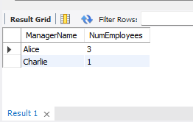

SELECT e1.Name AS ManagerName, e1.Salary

FROM Employee e1

JOIN Employee e2 ON e1.EmpID = e2.ManagerID

GROUP BY e1.EmpID, e1.Name, e1.Salary

HAVING e1.Salary > AVG(e2.Salary);

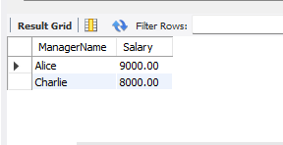

SELECT DISTINCT e2.Name AS SecondLevelManager

FROM Employee e1

JOIN Employee e2 ON e1.ManagerID = e2.EmpID

JOIN Employee e3 ON e2.ManagerID = e3.EmpID

JOIN Department d ON e1.DeptID = d.DeptID;

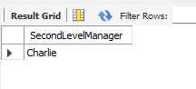

SELECT EmpID, Amount

FROM Incentives

WHERE Date BETWEEN '2019-01-01' AND '2019-01-31'

ORDER BY Amount DESC

LIMIT 1 OFFSET 1;

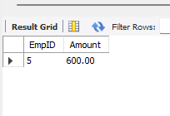

SELECT e1.Name AS EmployeeName, e2.Name AS ManagerName

FROM Employee e1

JOIN Employee e2 ON e1.ManagerID = e2.EmpID

WHERE e1.DeptID = e2.DeptID;

